1. INTRODUCTION
Document classification is the task of grouping documents into categories based upon their content. Document classification is a significant learning problem that is at the core of many information management and retrieval tasks. Document classification performs an essential role in various applications that deals with organizing, classifying, searching and concisely representing a significant amount of information. Document classification is a longstanding problem in information retrieval which has been well studied.
Automatic document image classification can be broadly classified into three categories. These are Supervised document classification, Unsupervised document classification, and Semi-supervised document classification.
Never before has document classification been as imperative as it is at the moment. The expansion of the internet has resulted in significant increase of unstructured data generated and consumed. Thus there is a need for content-based document classification so that these documents can be efficiently located by the consumers who want to consume it. Search engines were precisely developed for this job. Search engines in their early days used to work by constructing indices and find the information requested by the user however it was not very uncommon that search engines at times may return a list of documents with poor correlation. This has led to development and research of intelligent agents that makes use of machine learning in classifying documents .
In the present work we focus on newspaper document classification into different predefined categories. Newspapers are typically published daily or weekly and News magazines are either weekly or monthly and both have different format. General-interest news papers typically publish news articles and feature articles on National and International news as well as Local news. The news includes political events and personalities, business and finance, crime, weather, and natural disasters, health and medicine, science, computers and technology, sports and entertainment, society, food and cooking, clothing and home fashion, arts, etc.
Usually the newspapers have a complex layout as shown in Fig-1to Fig-4 where Newspaper is divided into sections, for each of those major groupings labelled A, B, C, and so on, with pagination prefixes yielding page numbers A1-A20, B1-B20, C1-C20, and consists of both text and graphics with varied font size and styles and so on.
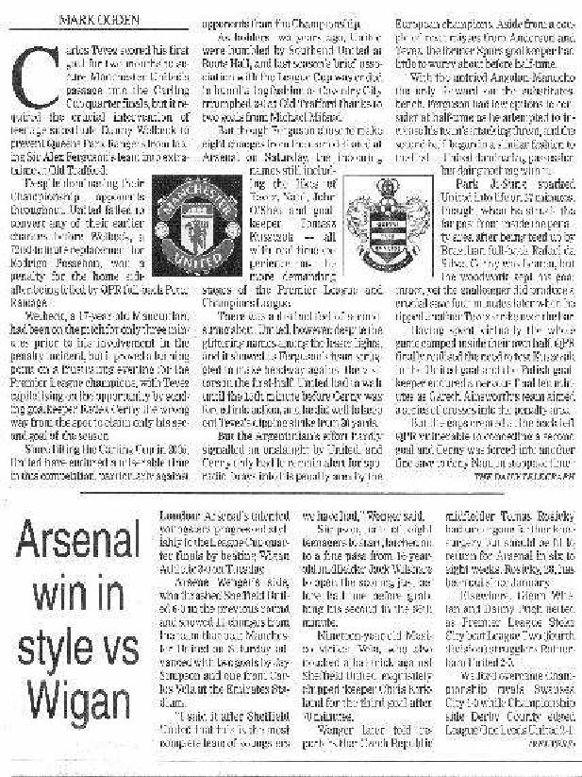
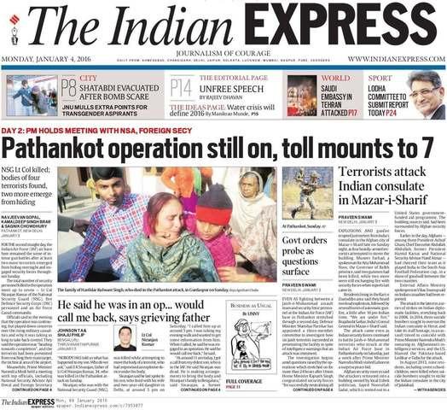
Fig 1 Sample Newspaper Image Fig 2 Sample Newspaper Image showing a single
character with large size in a word

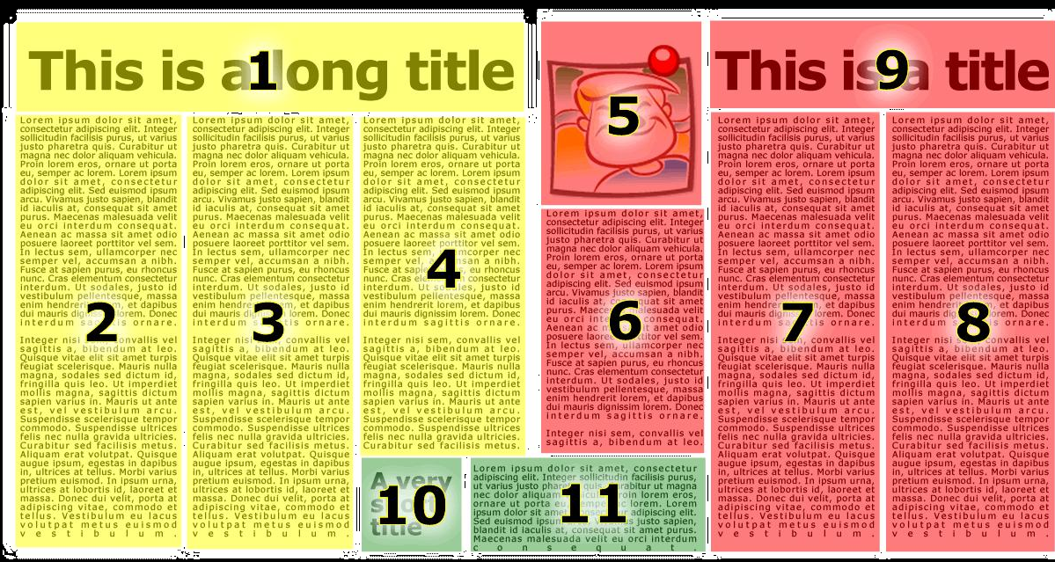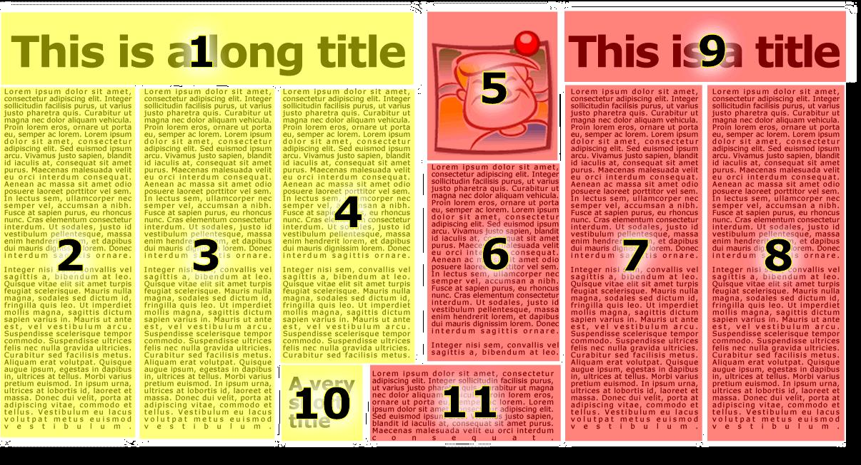
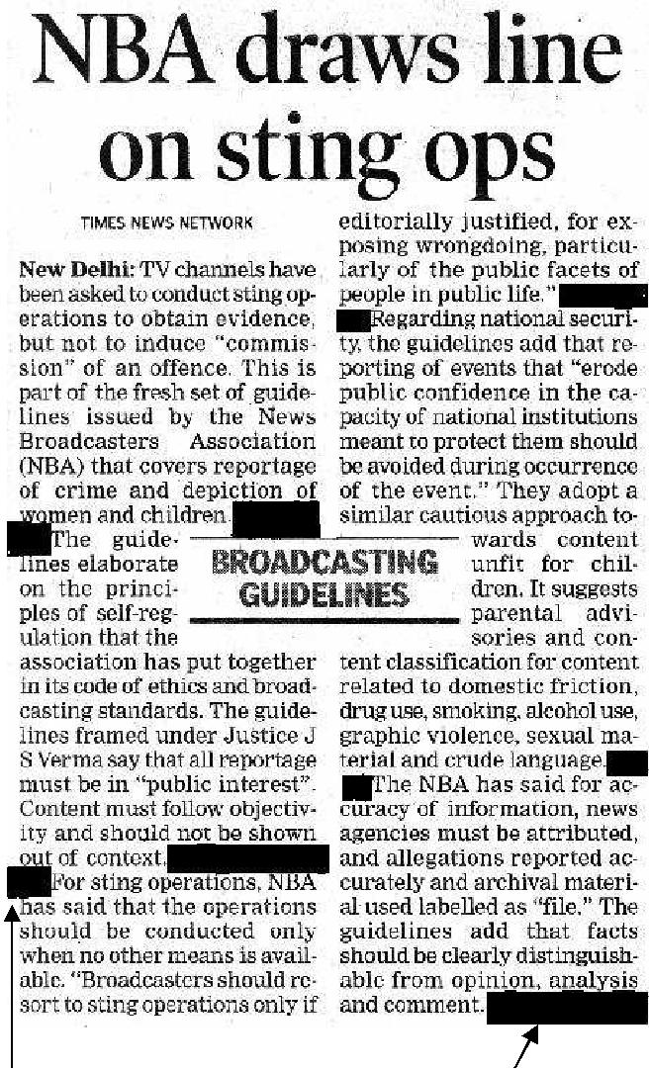
Fig 3 a) Sample Newspaper Image for Incorrect clustering b) Sample Newspaper Image for correct clustering

Fig 4 Sample Newspaper Image with an intrusion in between two columns
The above examples illustrate some of the things to be focused while classifying the newspaper images Fig 1 says while segmenting the text below the image (caption) need to be taken care, Fig 2 says different font sizes to be considered while segmenting, Fig 3 says after segmenting the image next task in classifying the document is group the segmented blocks according to their similarity, Fig 4 says intrusions in form of image or text appears in between the two columns to be considered while segmenting.
Most traditional papers also feature an editorial page containing editorials written by an editor and expressing an opinion on a public issue, opinion articles called "op-eds" written by guest writer and columns that express the personal opinions of columnists.
A wide variety of material has been published in newspapers. Besides the aforementioned news, information and opinions, they include weather forecasts, criticism and reviews of the arts and of local services. As of 2017, newspapers may also provide information about new movies and TV shows available on streaming video services like Netflix. Newspapers have classified ad sections where people and businesses can buy small advertisements to sell goods or services as of 2013, the huge increase in Internet websites for selling goods, such as Craigslist and eBay has led to significantly less classified ad sales for newspapers.
Present available newspapers are The Times of India, Hindustan Times, The Hindu, The Telegraph, Deccan Chronicle, Mumbai Mirror, The Economic Times, Daily News Analysis, The Tribune, The New Indian Express etc.
From the above all it is clear that most of the data is stored in the form of text and the exponential growth of data triggers an increase in the number of text mining research. Since those conditions may lead us to enter the information explosion era, an era where the data cannot be mantained easily. One of the interesting text mining researches that may prevent us to enter information explosion era is document classification. Document classification is a way to automatically categorize uncategorized data into several predefined categories. As the data are grouped based on their topics, it will make the data management easier. Text classification can also give brief information about documents to the readers before they read through it.
Thus our work here is to classify the newspapers images into their predefined categories like sports, education, entertainment, politics, technology, business etc, it is important for user to analyze the newspaper document before further processing.
Some of the applications that make use of the above techniques for document classification are Email routing, Language identification, Readability assessment, indexing, categorization searching etc.

2. LITERATURE REVIEW
This section deals with survey of work that has been carried out based on classifying different categories of newspaper document .
[1]. Nawei Chen et. al. (2007) highlighted an article based on “A survey of document image classification: problem statement, classifier architecture and performance evaluation”. Document image classification is an important step in Office Automation, Digital Libraries, and other document image analysis applications. There is great diversity in document image classifiers: they differ in the problems they solve, in the use of training data to construct class models, and in the choice of document features and classification algorithms. Authors projected this diverse literature using three components: the problem statement, the classifier architecture, and performance evaluation. This brings to light important issues in designing a document classifier, including the definition of document classes, the choice of document features and feature representation, and the choice of classification algorithm and learning mechanism. Authors emphasize techniques that classify single-page typeset document images without using OCR results. Developing a general, adaptable, high-performance classifier is challenging due to the great variety of documents, the diverse criteria used to define document classes, and the ambiguity that arises due to ill-defined or fuzzy document classes
[2]. G.G.Naidu et. al. (2017) highlighted an article based on “Survey of methods for Effective Image Classification and Identification”. In order to improve the retrieval accuracy of content-based image retrieval systems, research focus has been shifted from designing sophisticated low-level feature extraction algorithms to reducing the ‘semantic gap’ between the visual features and the richness of human semantics. This work attempts to provide a comprehensive survey of the recent technical achievements in high-level semantic-based image retrieval. Major recent publications are included in this survey covering different aspects of the research in this area, including low-level image feature extraction, similarity measurement, and deriving high-level semantic features.
[3] Komal P.Bhoyar et. al. (2014) presents paper entitled “A Review Paper On Automatic Text And Image Classification For News Paper”, an innovative and effective technique. In this it includes the process of pattern deploying and pattern evaluation to improve the effectiveness for finding the relevant information. Web newspaper provides the valuable source of information. It may be in the format of text or may be in the format of image. In order to take the more advantage from the available information, we are applying the text mining and image mining technique using the fallowing steps 1) Basic image processing techniques 2)converting documents into number of words 3)stop word removal process 4) N-gram algorithm for approximate matching of words by converting the sequence of words into set of N-gram 5)Naive Bayes Classifier based on Bayes theorem largely used because of independent assumptions which allows all parameters or attributes of documents for each to be learn separately 6) clustering using K-means algorithm and LWC algorithm used to clustered classified data form naive bayes algorithm into database with its special attributes to retrieve the news item to user view and use the clustered data and their special attributes at the time of searching. Similarly LWC algorithm is also used to cluster data but also sequencing the data and is also used to search nearest data matching document having highest similar words. Hence the work conform the quality and robustness .
[4] Krishnalal G et. al. (2010) proposed an intelligent system for online news classification entitled as “A New Text Mining Approach Based on HMM--SVM for Web News Classification”. System is designed to extract the keywords from the online news paper content and classify it according to the pre defined categories. Three different stages are designed to classify the content of online newspapers such as (1) Text pre-processing (2) HMM based Feature Extraction and (3) Classification using SVM. Data have been collected for experimentation from The Hindu, The New Indian Express, Times of India, Business Line, and The Economic Times. The experimental results are based on the news categories such as sports, finance and politics and their accuracies are 92.45%, 96.34% and 90.76% respectively. These results are very good compared to that of other text classification methods.
[5] A.Bandyopadhyay et. al. (2011) proposed a novel approach for document page segmentation entitled “Layout Segmentation of Scanned Newspaper Documents”. Layout segmentation algorithms found in published papers often rely on some predetermined parameters such as general font size, distances between text lines, presence of images. Variations of these parameters in real document images greatly affect the performance of algorithms. In this paper authors present a simple and novel approach for document page segmentation which are complex in nature, here authors dealt with the segmentation of a scanned document into images, headers, columns and finally into paragraphs. First separate the image and fonts of greater size and then with column separation, finally into smaller paragraphs and have achieved accuracy of 100% for English column detection, 97.6 % for Bengali , 99.35% of English language paragraph detection, 97.77% for Bengali. Some erroneous results were found for Bengali images where two paragraphs were getting placed inside the same block and was due to problem in the threshold of images, it is found that an image or a line of text occur in between two columns for such cases proposed algorithm may suffer problem of over segmentation are to be considered for future work.
[6] Rupinder Pal Kaur et. al. (2017) presents a review on techniques of segmenting newspaper images into various blocks entitled “A Survey on Newspaper Image Segmentation Techniques”. Authors studied various research papers written by various authors and keenly analyzed pros and cons of each technique. various techniques proposed by different authors for segmenting newspaper images connected component analysis and texture analysis, surrounding box height and RLSA, connected lines, RLSA and interblock distance, image projection profiles and FFT, X Y cut algorithm, Edge detection and merging etc. Applied on English, greek, Arabic, roman newspapers reviewing all above the common resulted limitations are sub titles are not extracted accurately, degraded images could not segment properly, could not handle text blocks if text is not well separated from background, geometrical features failed to segment a block if it contains font of two different sizes for example text in caption. New algorithms need to be designed to address all the above problems. Overall most of the combination of techniques are used for segmentation which give better results.
[7] Ritu Garg et.al. (2013) proposed a novel framework for learning optimal parameters for text graphic separation in the presence of complex layouts entitled “Text Graphic Separation In Indian Newspapers”. The learning problem has been formulated as an optimization problem using EM algorithm to learn optimal parameters depending on the nature of the document content that adaptively learns parameters based on the content of the document for text graphic separation in newspaper articles. The approach utilizes the spatial texture properties over a local neighbourhood, the dimensions of which are also one of the parameters that are learned during optimization. Each script is represented as a distribution over edge direction histogram (EDH) features. These distributions are used to model the script characteristics that are learned from the training data using Expectation Maximization (EM) algorithm. Further the adaptive segmentation scheme works at pixel level where the estimation of optimal values for P/N ratio and local neighbourhood size wi(m,n) accuracy thus obtained 87-100% , accuracy was 100% for pages with only text regions. The errors were due to noise and degraded images hence in future need to improve segmentation results by experimenting with different pre-processing routines and also by adding more newspapers images with complexity.
[8] Seyyed Mohammad Hossein Dadgar et. al. (2016) proposed a new approach for news classification entitled “A Novel Text Mining Approach Based on TF-IDF and Support Vector Machine for News Classification”. In order to classify news texts the approach was comprised of three different steps: 1) text preprocessing, 2) feature extraction based on TF-IDF, and 3) classification based on SVM. This approach was trained through the SVM classifier which was selected because it could support data with high dimensions. Using the BBC dataset and five groups of the 20Newsgroup dataset, the news group was evaluated. The classification precision was obtained 97.48% and 94.93% for the BBC dataset and the 20Newsgroup dataset respectively. These results were in good agreement with those obtained from other methods of text classification. Moreover, the F scale was used to obtain a single value between precision and recall. Through using this scale, authors found the best group in the BBC set to be sports with 99.22%, whereas in the 20Newsgroup, the best group was politics with 97.34%.
[9] Wei-Ta Chu et. al. (2016) proposed a system entitled “Advertisment Detection, Segmentation, and Classification for Newspaper Images and Website Snapshots”, in order to facilitate advertisement studies, The Laplacian of Gausian Filter is used to detect and enhance edges in the image, then used the Otsus method to binarize the edge image and find 8-connectivity connected components from the binary map. Two types of filters are designed to remove non-advertisement regions. First area coverage thus check whether both height and width of each candidate region meet the specified criteria. Second rule most advertisements are well bounded. Applying the sobel operator to detect the edges and project pixels to further filter out non-advertisement candidates. Then extract CNN features to describe candidate region and construct a SVM classifier to discriminate advertisement and non-advertisement. The evaluation results show that the proposed method performs well for both newspaper images and website snapshots. Face some limitations needed to be solved in future one of them is classification accuracy of politics advertisements.
[10] Anukriti Bansal et.al. (2014) presents a novel learning based framework for the problem of article extraction in newspaper images entitled as “Newspaper Article Extraction Using Hierarchical Fixed Point Model”. The work is focused on Region labelling and article extraction. The input to the system comprises blocks of text and graphics, obtained using standard image processing techniques. The ﬁxed point model approach is very general and is not based on a set of rules and uses contextual information and features of each block to learn the layout of newspaper images and attains a contraction mapping to assign a unique label to every block and implemented the ﬁxed point model using SVM and KLR as contextual prediction function. We use a hierarchical model which works in two stages. In the ﬁrst stage, a semantic label (heading, sub-heading, text-blocks, image and caption) is assigned to each segmented block. The labels are then used as input to the next stage to group the related blocks into news articles. The experimental results show that our method is efﬁcient in correctly identifying the news articles and provide an alternative to most of the present heuristic rule based systems. Accuracy obtained using SVM 76.35%, KLR 71.4% can be further improved by adding more newspaper images with different layout in the training set. Future work includes a comprehensive analysis of the applicability of the proposed approach to larger datasets of newspapers and other types of documents.
[11] Phillip E Mitchell et. al. (2004) presents an algorithm that performs automated segmentation and classification of newspaper images entitled as “Connected Pattern Segmentation and Title Grouping in Newspaper Images”. The algorithm discusses a technique for segmenting components that are connected to other components and presents another technique to correctly group titles and subtitles. The algorithm uses a bottom-up approach to initially segment the image, classify patterns and extract text lines. The classified patterns are then merged into complete regions. The algorithm is tested on a set of complex newspaper images taken from the First International Newspaper Segmentation Contest (FINSC) which are front pages from various English and Greek newspapers and authors use the Newspaper Component Detection Metric (NCDMi) to evaluate the algorithms performance based on counting the number of matches between the regions detected by the algorithm and the regions in the ground truth. Finally, the Newspaper Segmentation Metric (NSM) for our algorithm is calculated as 76.0% a vast improvement on the contest results, and is close to twice the highest score of 38.7%. Factor that affected the results across all classes is image quality.
[12] Ari Aulia Hakim et. al. (2014) have developed an online news article classifier entitled “Automated Document Classification for News Article in Bahasa Indonesia based on Term Frequency Inverse Document Frequency (TF-IDF) Approach”. TF-IDF algorithm to categorize online news articles. TF-IDF has a high dependency to the lexicon; The online news articles classification by using computer is more effective than human classification, to categorize the articles, human takes 89 hours to classify the articles. Even though human can do it faster than computer, but the fact that human can only work for 8 hours a day could make the process longer than a computer that can do it 24 hours a day. TF-IDF algorithm promises an high accuracy, but it still has some weakness, one of them is to categorize the article that belong to a category but it contains a lot of word that describe another category, since this algorithm considers every word’s weight and make the system create a wrong output. The other weakness of this algorithm is that this algorithm takes a lot of time due to the large number of the word in the dictionary. It has been proved by the output of this research; the average accuracy is 98.3% which is quite satisfying.
[13]. Adam W.Harley et. al. (2015) have presented a paper on “Evaluation of Deep Convolutional Nets for Document Image Classification and Retrieval”. A new state-of-the-art for document image classiﬁcation and retrieval have been proposed using features learned by deep convolutional neural networks (CNNs). Generic features extracted from a CNN trained on ImageNet exceeded the performance of the state-of-the-art alternatives, and ﬁne-tuning these features on document images pushed results even higher. Interestingly, experiments also showed that given sufﬁcient training data, enforcing region-speciﬁc feature-learning is unnecessary, a single CNN trained on entire images performed approximately as well as an ensemble of CNNs trained on speciﬁc subregions of document images. Overall proposed approach CNN approach to document image representation exceeds the power of hand-crafted alternatives.
[14] Roberto Beretta et. al. (2011) proposed a methodology to evaluate newspapers article identiﬁcation algorithms entitled “Performance Evaluation of Algorithms for Newspaper Article Identiﬁcation”. Approach is based on well-established tools from graph theory in particular, authors reduce the newspaper article clustering problem to a speciﬁc graph clustering problem, that is therefore evaluated using the appropriate coverage and performance measures with cov=0.941 and perf=0.818. The advantages of proposed approach are twofold on one side, the proposed measures correctly detects that not all the errors are equals, i.e. some errors are worse than others, and the scores are assigned properly. On the other side, work shows how to reverse the reduction, in order to exploit the large number of graph clustering algorithm available indeed, given a graph clustering algorithm, to obtain a full working newspaper article identiﬁcation algorithm we only need to deﬁne a similarity measure between units in the article and provide some examples, using a speciﬁcally designed dataset. Finally, would like to point out that both our dataset, together with its ground-truth base, and the software tool, that implements the proposed approach, are freely available.
[15] Isuru Jayaweera et. al. (2015) presents an intelligent crime analysis system entitled “Crime Analytics: Analysis of Crimes Through Newspaper Articles”. The proposed system is a web-based system which comprises of crime analysis techniques such as hotspot detection, crime comparison and crime pattern visualization. Sri Lankan English newspapers (Daily Mirror, The Island, and Ceylon Today) are used as the source for details of crime incidents. Newspaper articles are crawled using a focused crawler and they are classified using a SVM based classifier. Required entities are extracted from classified crime articles and duplicate detection is performed. By using preprocessed data, crime analysis operations are performed and results are displayed using web based GUI. Unlike most systems, this system consists of a rich and simplified environment that can be used effectively for processes of crime analysis and is open to anyone who is interested in crime analysis. Crime prediction is expected to be implemented in future to enhance the functionality of the system. Comprehensiveness of the news article collection can be further improved by extending the news article crawler to crawl more news websites. Linguistic knowledge (WordNet, Ontology, etc.) can be incorporated with the document classifier module in order to improve the accuracy of the classification process. In addition the entity extraction module can be improved by incorporating more rules which will improve the accuracy and the comprehensiveness of the entity extraction process.

- OBJECTIVES OF THE PROPOSED RESEARCH WORK
The objectives of the proposed Research work are as follows
- To deal with complex layouts of newspaper document and its legibility.
- To find and reveal the percentage of particular category of news in particular year, month, weakly and daily basis.
- Time gap consideration while selecting newspaper images.
- To deal with the segmentation problems
a )To segment the caption properly.
b) Over segmentation problem i.e many a times text or graphics occur in between two columns. This creates a problem of segmenting the columns properly.
- To deal with the single text of varying size.
- To deal with the situation where Subheading and content discrimination if both the font sizes are same.
- To deal with ex: “The terror attack on Sri Lankan cricket player at Lahore”. Contains some features that can mislead the classifier to classify the news as sports news even though it belongs to other category.
- To deal with noisy images, degraded images and time complexity of system.
- STUDY AREA AND METHODOLOGY
Study Area
Image processing is a method to perform some operations on an image, in order to get an enhanced image or to extract some useful information from it. It is a type of signal processing in which input is an image and output may be image or characteristics/features associated with that image.
The proposed work is towards document image classification. Document classiﬁcation is an important task in document processing, used in various contexts. Here, a document refers to a single-page typeset document image. The document image may be produced from a scanner, a fax machine, camera or by converting an electronic document into an image format(e.g.TIFF or JPEG). We focus on classiﬁcation of mostly-text documents, using image-level or structural features. There is great diversity in document classiﬁers. Classiﬁers solve a variety of document classiﬁcation problems, differ in how they use training data to construct models of document classes, and differ in their choice of document features and recognition algorithms.
The following four aspects may be considered to characterize classiﬁer architecture (1) document features and recognition stage (2) feature representations, (3) class models and classiﬁcation algorithms and (4) learning mechanisms.
Finally, Performance evaluation task is carried out to gauge the performance of a classiﬁer, and to permit performance comparisons between classiﬁers. The diversity among document classiﬁers makes performance comparisons difﬁcult. Issues in performance evaluation include the need for standard data sets, standardized performance metrics, and the difﬁculty of separating classiﬁer performance from pre-processor performance.
Methodology
In document image classification work is to classify document images based on predefined categories and is performed by following phases.
Image Acquisition

Postprocessing
Classification
Feature Extraction
Segmentation
Preprocessing

Fig 1: Block diagram of the proposed research work

Image Acquisition
Image Acquisition is a process of obtaining an electronic image of paper based document. In most cases a flat-bed scanner is used, however in digital libraries book scanners can be considered, whereas in recent years portable devices such as digital cameras and mobile phones are used as well.
Preprocessing
Preprocessing operations in document image analysis transform the input image into an enhanced image more suitable for further analysis. Image to image transformations in Document analysis belongs to four main classes: Filtering, Geometrical Transformations (eg: skew detection) , finally thinning or boundary detection to enable easier subsequent detection of pertinent features and objects of interest.
The filtering transforms the input into an image whose value in the generic position (i,j) is usually a function of the input values in a neighbourhood of the point (i,j). The three main classess of filtering operations are Binarization, Noise Reduction. An example of machine learning applications for filtering is based on the well known property of universal approximation of neural networks, and in particular of the Multi-Layer Perceptron(MLP).
Segmentation
Segmentation is very important and challenging process of image processing. Image segmentation is the techniques used to partition an image into meaningful parts that have similar features and properties. The aim of segmentation is representing an image into meaningful and easily analyzable way. Image segmentation is the first step in image analysis. The main goal of image segmentation is to divide an image into several parts/segments having similar features or attributes. The main applications of image segmentation are Medical imaging, Content-based image retrieval, Automatic traffic control systems, Object detection and Recognition Tasks, etc.
The image segmentation can be classified into two basic types: Local segmentation concerned with specific part or region of image and Global segmentation concerned with segmenting in whole image, consisting of large number of pixels.
The image segmentation approaches can be categorized into two types based on properties of image. Discontinuity detection based approach and Similarity detection based approach.
The following are the techniques that come under this are: region growing, thresholding techniques and region merging and splitting. All these techniques divide an image with the help of similar pixels. This approach is also used for clustering the data. In this approach, clusters of pixels are formed that have similar features.
Image Segmentation has several techniques for dividing the images into segments. Each technique has its own features. All these techniques follow mainly two basic approaches for image segmentation. The two approaches are: region based approach and edge based approach. All techniques of image segmentation is broadly divided into three parts. These are as follows: Structural Segmentation Techniques, Stochastic Segmentation Techniques, Hybrid Techniques, the following are few Image Segmentation methods Thresholding Method, Edge Based Segmentation method, Region Based Segmentation Method, Clustering Based Segmentation Method, Watershed Based Method, Partial Differential Equation Based Segmentation Method, Artificial Neural Network based segmentation method.
Segmentation of scanned newspaper documents particularly layout segmentation is based on certain parameters like general font sizes, distances between text lines, presence of images and document scan resolutions, headers, columns and finally into paragraphs, tables, drawings.
Feature extraction
Feature extraction is an important step in the construction of any pattern classification and aims at the extraction of the relevant information that characterizes each class. In this process relevant features are extracted from objects/ alphabets to form feature vectors. These feature vectors are then used by classifiers to recognize the input unit with target output unit. It becomes easier for the classifier to classify between different classes by looking at these features as it allows fairly easy to distinguish. Feature extraction is the process to retrieve the most important data from the raw data. Feature extraction is finding the set of parameter that define the shape of a character precisely and uniquely. In feature extraction phase, each character is represented by a feature vector, which becomes its identity. The major goal of feature extraction is to extract a set of features, which maximizes the recognition rate with the least amount of elements and to generate similar feature set for variety of instance of the same symbol. The widely used feature extraction methods are Template matching, Deformable templates, Unitary Image transforms, Graph description, Projection Histograms, Contour profiles, Zoning, Geometric moment invariants, Zernike Moments, Spline curve approximation, Fourier descriptors, Gradient feature and Gabor features.
Classification
Classiﬁcation is a process in which individual items (objects/patterns/image regions/pixels) are grouped based on the similarity between the item and the description of the group. Document Image classification is a complex process and may be affected by many factors. The classification of document being processed is required for their efficient recognization as it reduces number of searches, easy recognization of document and also reduces the chance of error at different stages during processing. A classifier associates the document with class, labeling an observed document image according to the class, region in to which it falls. The classification stage identifies each input document image by considering the detected features. The categorization of images greatly enhance the performance of document by filtering out the relevant document and the class to which it belongs. Classification of main document is done first followed by the sub-sections. A class prototype is stored in knowledge base .The incoming document is assigned to one of the classes, depending on the value of measure of nearness with the class prototype. This value is obtained by comparison of document under study and the class prototype. The document is assigned to the class with which highest value of the measurement is obtained. It is found that the performance of classification techniques varies with different data sets. Factors that affect the classifier’s performance are Data set, Type of attributes and System configuration. Simple classification methods/classifiers like Bayesian network, Decision Tree, Convolutional Neural Network, Naive Bayes, SVM, KNN, HMM, RNN are of prime importance to acquire information regarding the document under process.
Post-processing
The post-processing component (dependent on application) uses the output of the classifier to decide on some recommended action for the final decision.

5. EXPECTED OUTCOMES
Expected outcomes of the proposed work are as below
- To develop a Novel method to classify the document images by considering constituent parts of document image.
- Explore the unknown application areas of newly developed system.
- To Improve the accuracy of the system.
- Reduction in the training , testing and classification time
- To reach and solve the objectives of my research work.

REFERENCES
[1] Nawei Chen, Dorothea Blostein , “A survey of document image classification: problem statement, classifier architecture and performance evaluation”, IJDAR, vol.10,Issue 1, Springer-Verlag Berlin, Heidelberg May 2007 , pp.1-16.(Journal)
[2] G.G.Naidu,Y.Srinivas, “Survey of Methods for Effective Image Classification and Identification”, International Journal of Applied Engineering Research, Volume 12, Number 18 (2017), pp.7132-7136.(Journal)
[3] Komal P. Bhoyar, Neha S. Hiwase, Sneha K. Ankurkar, Prof. Preeti Bhagat “A Review Paper On Automatic Text And Image Classification For News Paper”, International Journal of Advanced Research in Electronics and Communication Engineering (IJARECE) Volume 3, Issue 2, February (2014).(Journal)
[4] Krishnalal G, S Babu Rengarajan , K G Srinivasagan “A New Text Mining Approach Based on HMM-SVM for Web News Classification”, International Journal of Computer Applications,Volume 1- No. 19 (2010), pp.0975 – 8887.(Journal)
[5] A. Bandyopadhyay, A.Ganguly, U.Pal “Layout Segmentation of Scanned Newspaper Documents” Journal of Computational Linguistics. Vol1,Issue 1, 2011, pp.05-10.(Journal)
[6] Rupinder Pal Kaur, Manish Kumar Jindal “A Survey on Newspaper Image Segmentation Techniques”, International Conference on “Recent Trends in Technology and its Impact on Economy of India”,24th oct 2017.(conference)
[7] Ritu Garg, Anukriti Bansal , “Text Graphic Separation In Indian Newspapers”, http://www.cse.iitd.ernet.in/~sumantra/publications/mocr13_text_graphics.pdf. 2013.
[8] A Novel Text Mining Approach Based on TF-IDF and Support Vector Machine for News Classification”
[8] Wei-Ta Chu, Han-Yuan Chang “Advertisment Detection,Segmentation, and Classification for Newspaper Images and Website Snapshots”, International Computer Symposium, IEEE, 2016.
[9] Anukriti Bansal, Santanu Chaudhury, Sumantra Dutta Roy, J.B. Srivastava “Newspaper Article Extraction Using Hierarchical Fixed Point Model”, 11th IAPR International Workshop on Document Analysis Systems,IEEE,2014.
[10] Phillip E Mitchella, Hong Yana “Connected Pattern Segmentation and Title Grouping in Newspaper Images”, 17th International Conference on Pattern Recognition (ICPR’04), IEEE,2004.(Conference)
[11] Ari Aulia Hakim, Alva Erwin, Kho I Eng, Maulahikmah Galinium, Wahyu Muliady , “Automated Document Classification for News Article in Bahasa Indonesia based on Term Frequency Inverse Document Frequency (TF-IDF) Approach”, IEEE,2014
[12] Adam W.Harley, Alex Ufkes, and Konstantinos G.Derpanis , “Evaluation of Deep Convolutional Nets for Document Image Classification and Retrieval”, International Conference on Document Analysis and Recognition (ICDAR),IEEE,2015,pp.991-995.(conference)
[13] Roberto Beretta, Luigi Laura “Performance Evaluation of Algorithms for Newspaper Article Identiﬁcation”, International Conference on Document Analysis and Recognition(ICDAR),IEEE,2010,pp.394-398.(Conference)
[14] Isuru Jayaweera, Chamath Sajeewa, Sampath Liyanage, Tharindu Wijewardane, Indika Perera, Adeesha Wijayasiri “Crime Analytics: Analysis of Crimes Through Newspaper Articles”, IEEE,2015.
[15] Abdessalem Bouzaieni,sabine baarat, “Automatic Annotation Extension and Classification of Documents Using a Probabilistic Graphical Model”, IEEE,2015,pp.316-320.
[16] Stephen O Hara, Bruce A. Draper, “Introduction to the bag of features paradigm for Image Classification and Retrieval”, Jan 2011.
[17] Rashad Ahmed, Wasﬁ G.Al-Khatib, Sabri Mahmoud, “A Survey on handwritten documents word spotting”, springer, Verlag London,2017,pp.31-47.
[18] Upendra Singh, Saqib Hasan, “Survey Paper on Document Classification and Classifiers”, International Journal of Computer Science Trends and Technology (IJCST), 2015,pp83-87.(Journal)
[19] Gaurav Kumar, Pradeep Kumar Bhatia, “A Detailed Review of Feature Extraction in Image Processing Systems”, International Conference on Advanced Computing & Communication Technologies, 2014.(conference)

Candidate’s Signature Guide’s Signature

Forwarded through the Research Centre

